Shaquille Regis

2000686590

CPE 301 – 1001

Design Assignment 1B

The purpose of this assignment is to learn about addressing modes using the X, Y and Z registers to create lists of numbers and perform arithmetic operations with said lists of numbers.

Part 1 requires us to store 99 numbers between 10 and 255 starting at address 0x0200 using the X, Y or Z registers. For this assignment, the address for the list is stored in X (r27:r26) and the numbers stored are sequential between 96 and 194 inclusive.

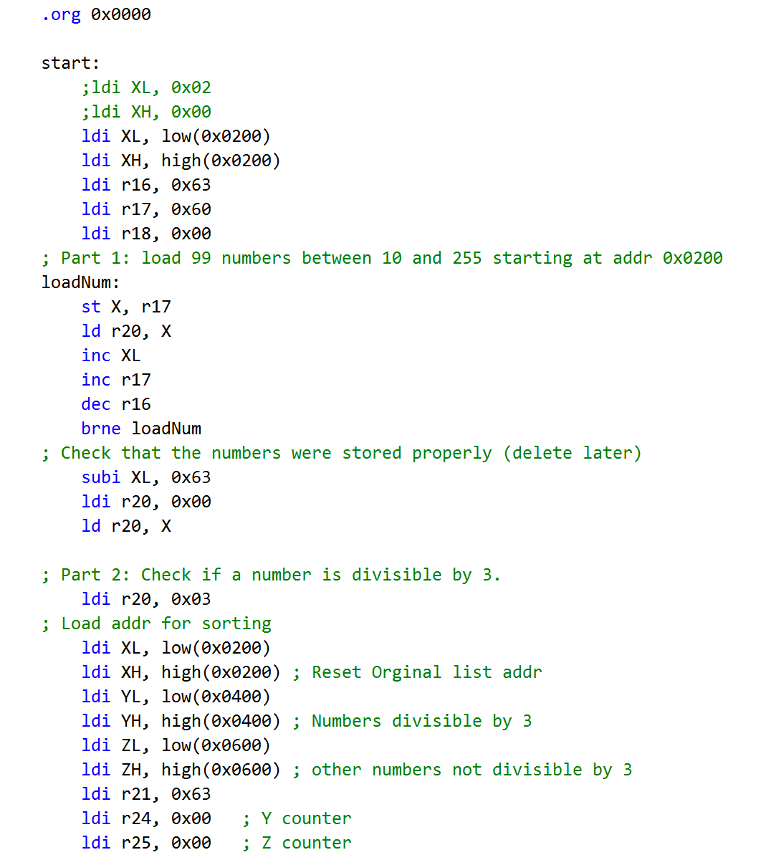

In part 2, we will sort the 99 numbers stored in X. Numbers divisible by 3 will be stored starting at address 0x0400 using the Y register. All other numbers will be store starting at address 0x0600 using the Z register. The count of numbers in Y and Z will be stored in r24 and r25 respectively.

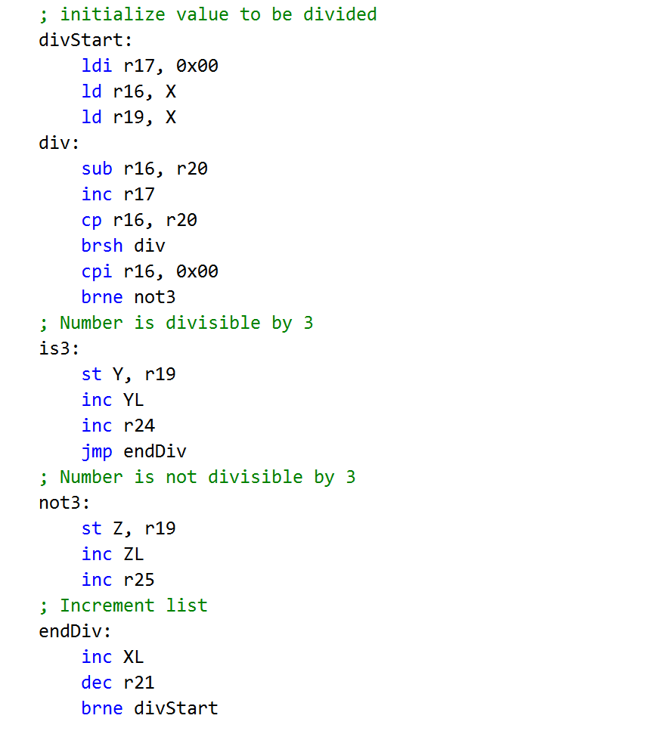

In part 3, we will be finding the cumulative sum of numbers stored at Y and Z individually. The sum of numbers at Y will be stored in the register pair r16:r17. The sum of numbers at Z will be stored in the register pair r18:r19.

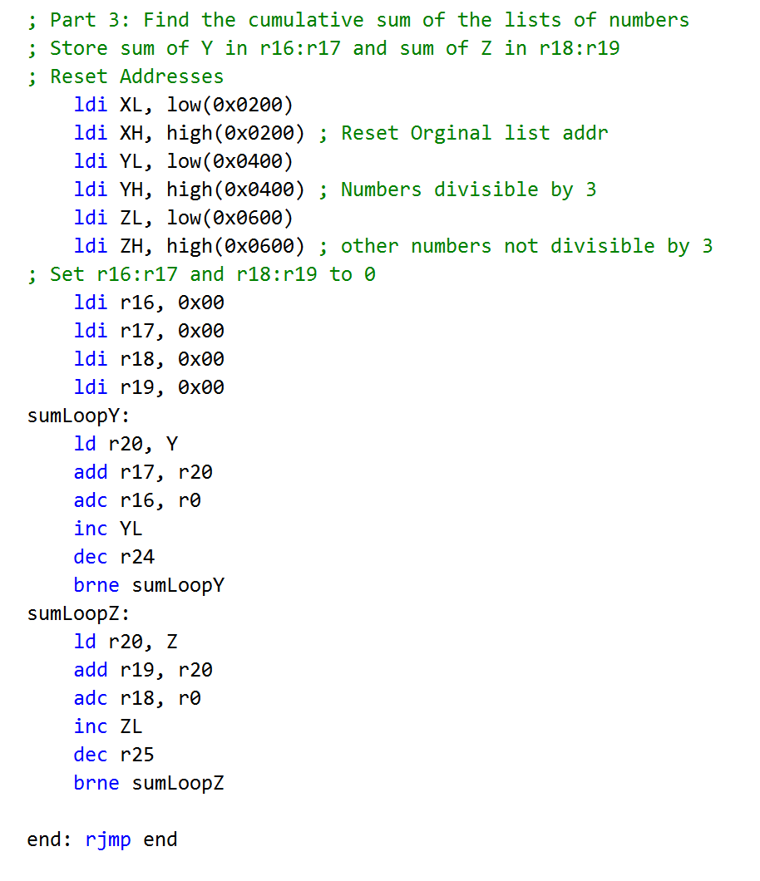

At the end of part 3, r16:r17 = 0x1290 and r18:r19 = 0x2583.

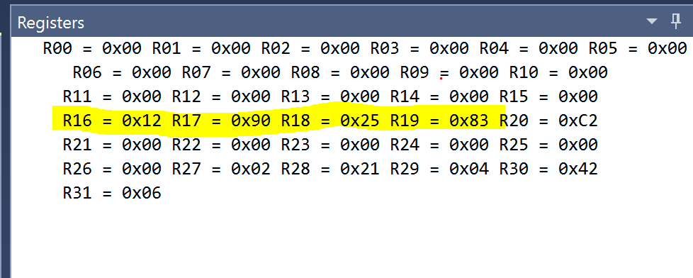

At 16MHz, the program takes 1,688.63 us.

